**Date:** 02/08/2016

**Roll No. and Name:** 14BCE154 Chauhan Prasiddh J.

**Course Code and Name:** Open Source Development Lab (CE703)

**Practical No.:** 1 (Python)

**AIM:** To develop a mini project in python to illustrate the implementation of MySQL Database connectivity

**Sample Input:**

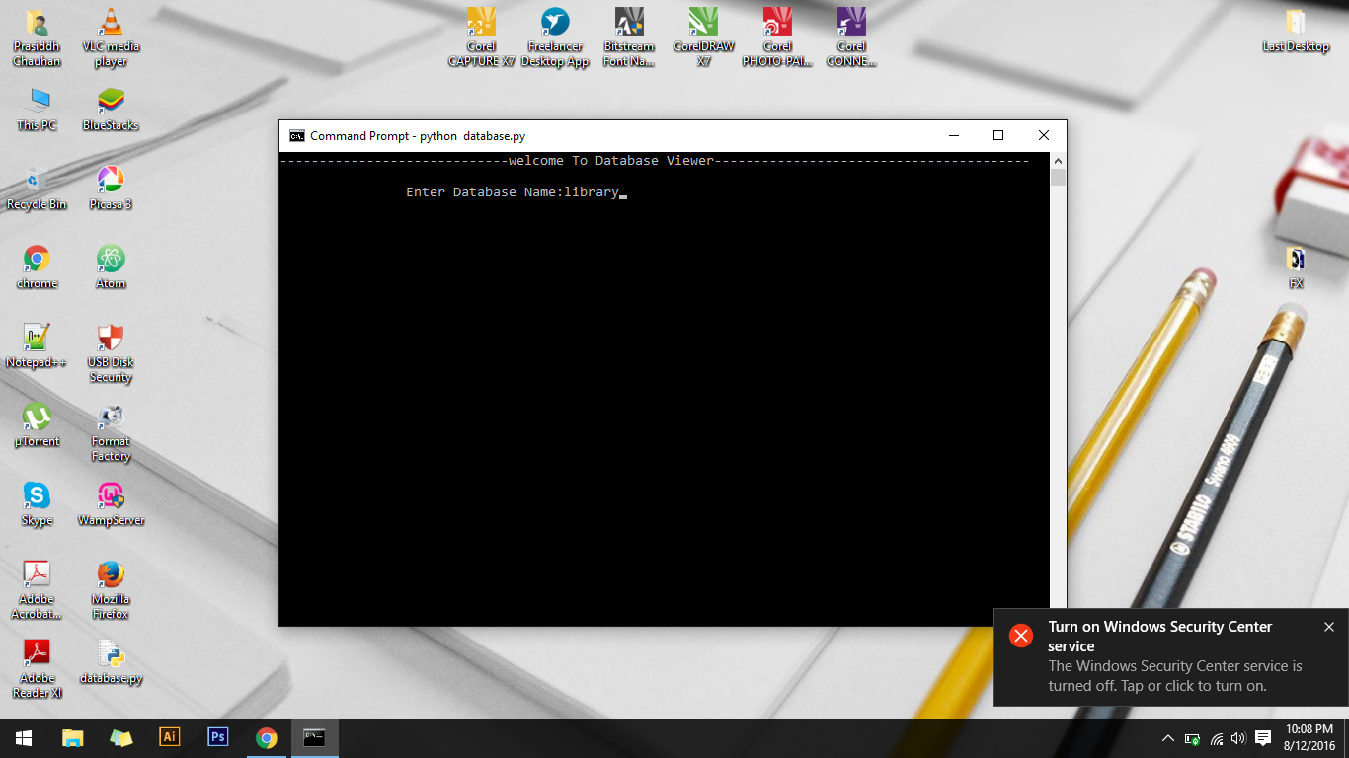

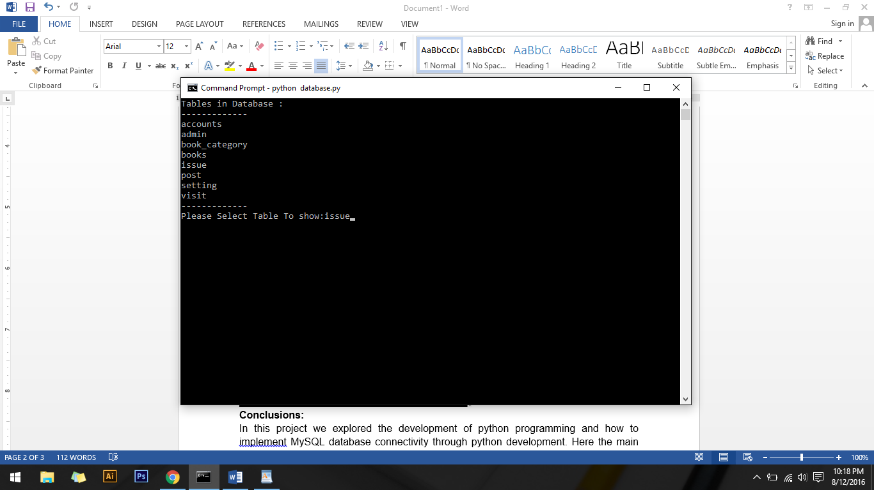

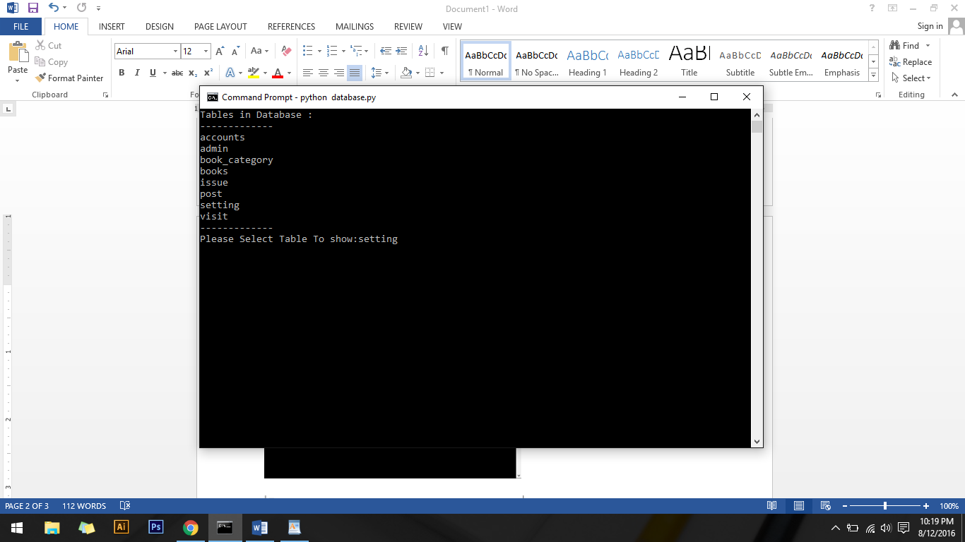

**Sample Output:**

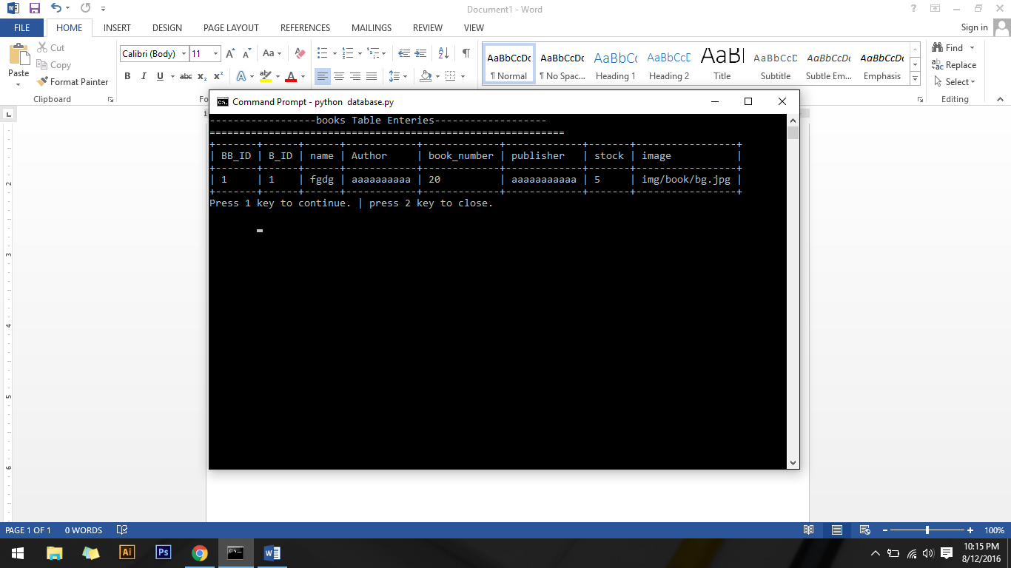

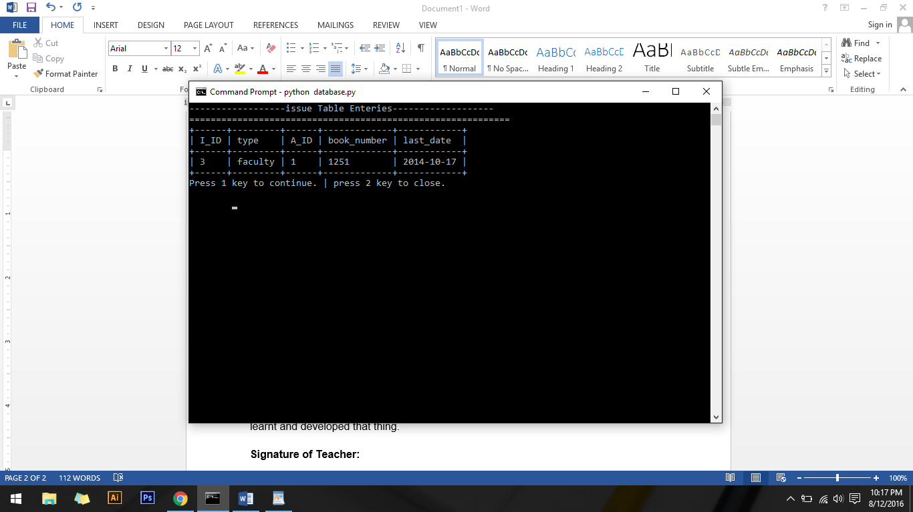

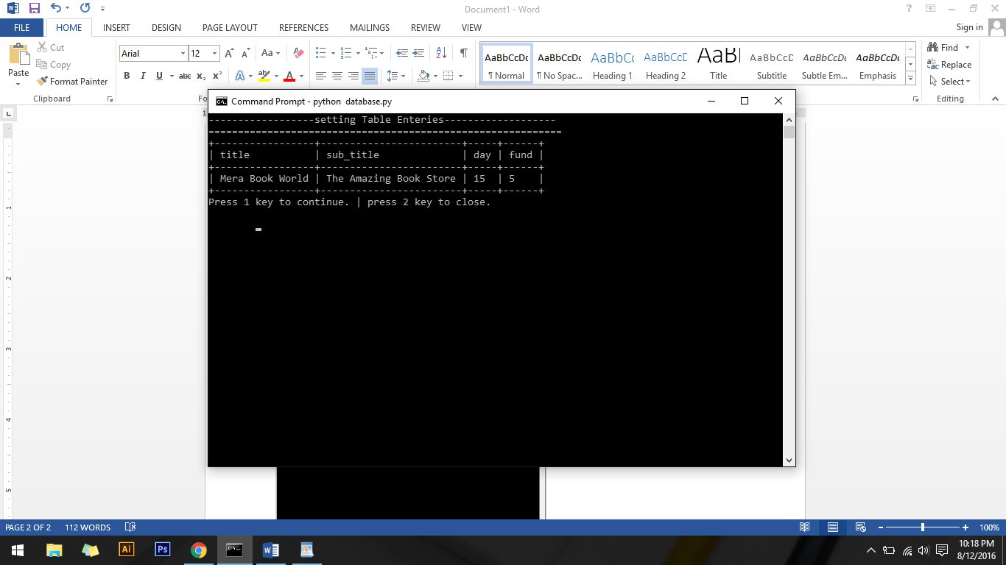

**Conclusions:**

In this project we explored the development of python programming and how to implement MySQL database connectivity through python development. Here the main part is to use the OS cmd command through importing the OS library and integration of both the things in python development environment which is new thing for us and we learnt and developed that thing.